**Task 1**

An online banking system design should contain a user, a client program (in a web browser), and a server on which a web server and an application server are running.

1. Draw a use case diagram for the functions “login”, “get balance” and “transfer money”.

**Use case diagram**

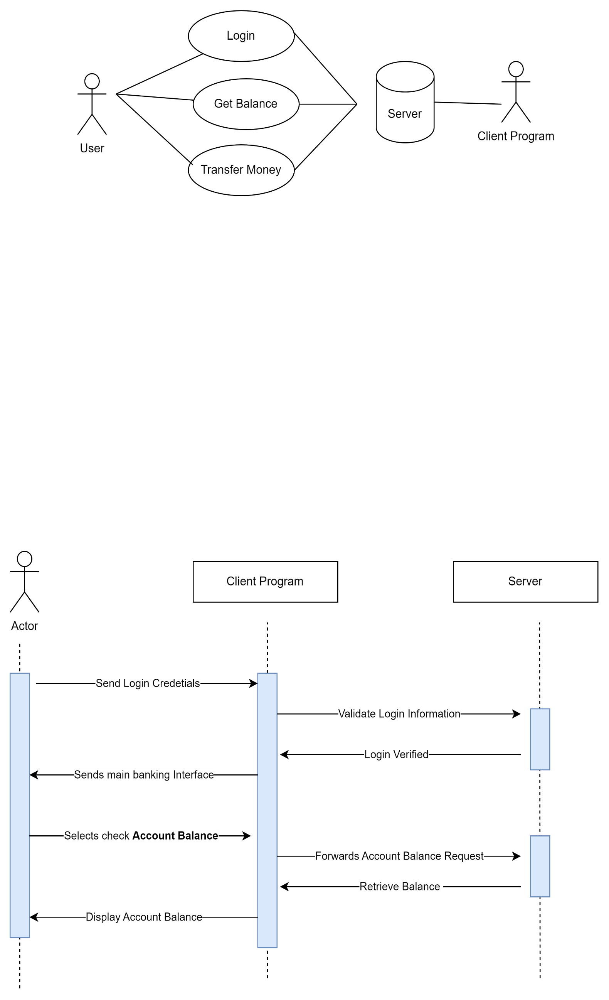

1. Draw a Sequence Diagram for the following interaction when a user logs into the system and requests an account balance. Decide which messages need to be sent between the architectural parts of the system.

